# Create the Spring Boot project and add the dependencies as below.

# Create a db and add the datasource info into the appli.properties file

* 1. Creating db

* 1. app.properties

# Create the entity/model Employee class in a new package under the main package

* 1. Add the fields
  2. Generate getters and setters
  3. Also generate the parameterized constr(exclude id). U wud also need to give the def constr.

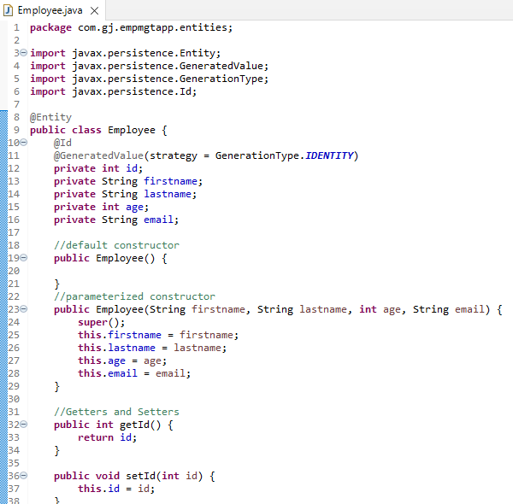

# Create the employeeRepo interface that extends JPARepo or CRUDRepo

# Create the employee controller class with the right annotations and mapping, also autowire the employee repo

# Now move to front end, create a React app

# Add bootstrap css to style the app. 2 ways to utilize it

* 1. Embed the cdn link in the
     1. Google search bootstrap cdn link and copy paste it in the head tag of index.html
  2. Npm command
     1. npm install bootstrap –save
     2. import it in index.js file

# Create react components

1. Create a new folder components and add a new file for employees list
2. Use the snippets to generate react class component rcc
3. Add the constructor(if not already) and the state
4. Create the table structure as below

1. To call this component, use <EmployeeList /> in App.js as below. Also make sure to import the component

# To get data from RestApi calls – install Axios

# Create service class

* 1. Create a new folder for api service calls and add a new employeeservice js file
  2. Import axios
  3. Create a js class and a getall method inside it
  4. Notice that not the class, but class object is exported as default

* 1. And then u can export this new class object in the employeelist component

# If there’s CORS policy issue , go to the Backend Java Controller Class and add the annotation for CrossOriginPolicy as below

# Create routing for the application

* 1. Install react router dom
     1. npm install react-router-dom
     2. Import Router, Routes(instead of Switch which is no longer used) and Route in App.js that’s where we are specifying the routes. See below
     3. Add the routes to the path

# Create the AddEmployee component

# Ggggb

# rrgrgr